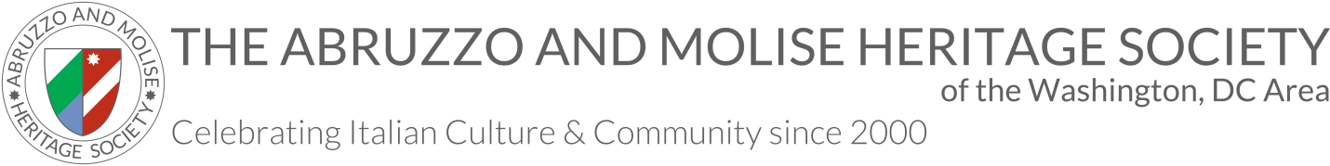

MEMBERSHIP APPLICATION/RENEWAL

Name #1 ____________________________________________________________________________________

Name #2(couple membership only): ________________________________________________________________

ADDRESS: ___________________________________________________________________________________

CITY/STATE/ZIP: _____________________________________________________________________________

E-MAIL: _____________________________________________________________________________________

PHONE: ______________________________________________________________________________________

PHONE2: _____________________________________________________________________________________

Please name Village/Region/Province in which you or your Italian ancestors were born:

Heritage #1: ___________________________________________________________________________

Heritage #2 (couple membership only): ______________________________________________________

WEDDING ANNIVERSARY (couple membership only): __________________________

MEMBER #1 BIRTHDAY: ______________________________

MEMBER #2 BIRTHDAY (couple membership only): ______________________________

E-MAIL #2: _____________________________________________________________________________________

Membership fees (please check all that apply):
Individual Membership, $30
Couple Membership, $55
Student Membership, $20
Associate Membership, $20 (for each member residing outside a 50-mile radius of Washington, DC)

AMOUNT ENCLOSED: $_________

Check the box if you would like to receive the Notiziario by electronic mail (email) only.

Please make your check payable to AMHS. Send to Lynn Sorbara, 2nd VP-Membership, 232 King Boulevard, Rockville, MD 20850.

